To Construct Real Life Network Synthetically of 10000 Nodes
and Discover Meaningful Insights & Visualization using NetworkX and Gephi Tools
Student Name: PRIYA SAMPAT JADHAV
PRN No.: 25039001021
Subject: Network Science
Maximum Marks: 30

1. Objective
The objective of this assignment is to construct a synthetic 10,000-node network using a stochastic Kronecker graph model, analyze its structural properties with NetworkX, visualize meaningful subgraphs, identify communities and calculate modularity, and then use Gephi for large-scale visualization and additional network statistics.

2. Tools and Technologies
Tool | Purpose
Python 3 | Network construction and analysis
NetworkX | Graph metrics, centrality, community detection and visualization
NumPy | Numerical computation and reproducible sampling
Pandas | Result tables and CSV export
Matplotlib | Network and metric visualization
Gephi 0.11.2 | Large-network visualization and statistics

3. Part I — Construction of 10,000-Node Kronecker Network
A stochastic Kronecker graph was generated using the following 2×2 initiator matrix. A fixed random seed of 42 was used for reproducibility.
 | 0 |  | 1
0 | 0.90 |  | 0.50
1 | 0.50 |  | 0.30
Parameter |  | Value
Target nodes |  | 10,000
Random seed |  | 42
Graph type |  | Undirected
Initiator matrix |  | 2 × 2
Edge attempts factor |  | 3
The implementation generates exactly 10,000 nodes without constructing a dense 16,384 × 16,384 probability matrix. The resulting enriched GEXF is used for Gephi.

4. Part II — NetworkX Analysis and Visualization

4.1 Visualization
Because a 10,000-node graph is difficult to interpret when every node is labelled, NetworkX visualizations use representative high-degree subgraphs, the largest connected component and community-level views. The complete network is retained for Gephi.
Visualization | Purpose
Degree distribution | Understand connectivity distribution
Top 1,000 — Spring layout | Inspect high-degree structure
Top 300 — Circular layout | Inspect central nodes
Top 200 — Shell layout | Inspect layered structure
Largest connected component | Study reachable structure
Largest community | Inspect community structure

4.2 NetworkX Required Metrics
The notebook supplied with this submission calculates the required NetworkX measures. The Gephi analysis of the same imported graph provides the following validated values.
Metric | Result
Number of Nodes | 10,000
Average Degree | 5.992
Network Diameter | 10
Graph Density | 0.001
Average Clustering Coefficient | 0.003 (Gephi validation)
Connected Components | 1,072 weakly connected components
Communities | 1,106 (modularity analysis)
Modularity | 0.332

4.3 Centrality Analysis
Degree centrality identifies highly connected nodes. Closeness centrality measures reachability within a connected component. Betweenness centrality identifies nodes positioned on shortest paths. For 10,000 nodes, the notebook uses NetworkX's sampling-based betweenness approximation with k = 500 source nodes.
Node | Degree | Closeness | Betweenness | Interpretation
0 | 109 | 0.320472 | 0.030171 | Highly connected and structurally prominent
512 | 75 | 0.296948 | 0.015882 | Highly connected and central
1024 | 76 | 0.302707 | 0.013433 | Highly connected and central
4 | 74 | 0.303429 | 0.019969 | High degree and centrality
2 | 70 | 0.301407 | 0.013833 | High degree and centrality

4.4 Community Detection and Modularity
Louvain community detection is used to partition the network. The Gephi modularity analysis reports modularity of 0.332 and 1,106 communities, indicating measurable community structure.
Community Result | Value
Modularity | 0.332
Number of communities | 1,106
Statistical inference communities | 3,049 (additional Gephi analysis)

5. Part III — Gephi Analysis
The enriched GEXF generated by NetworkX was imported into Gephi 0.11.2. ForceAtlas 2 can be used for large-network visualization. Community can be used for partition/coloring, while Degree or PageRank can be used for node sizing.
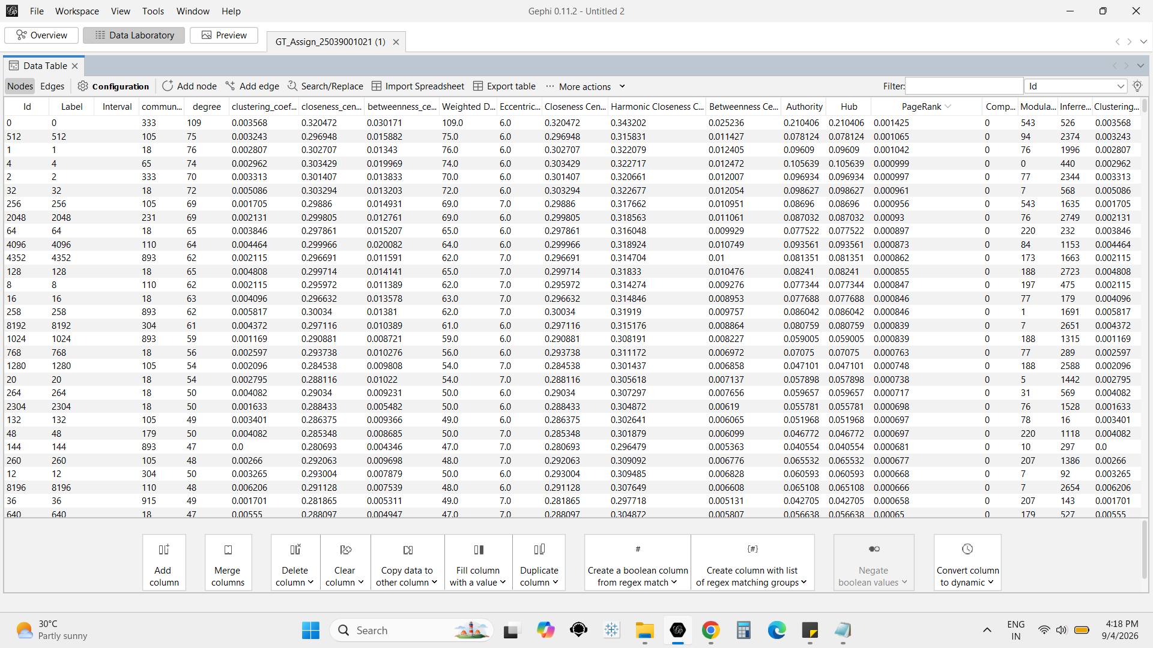
Figure 1: Gephi Data Laboratory showing imported network and calculated attributes.
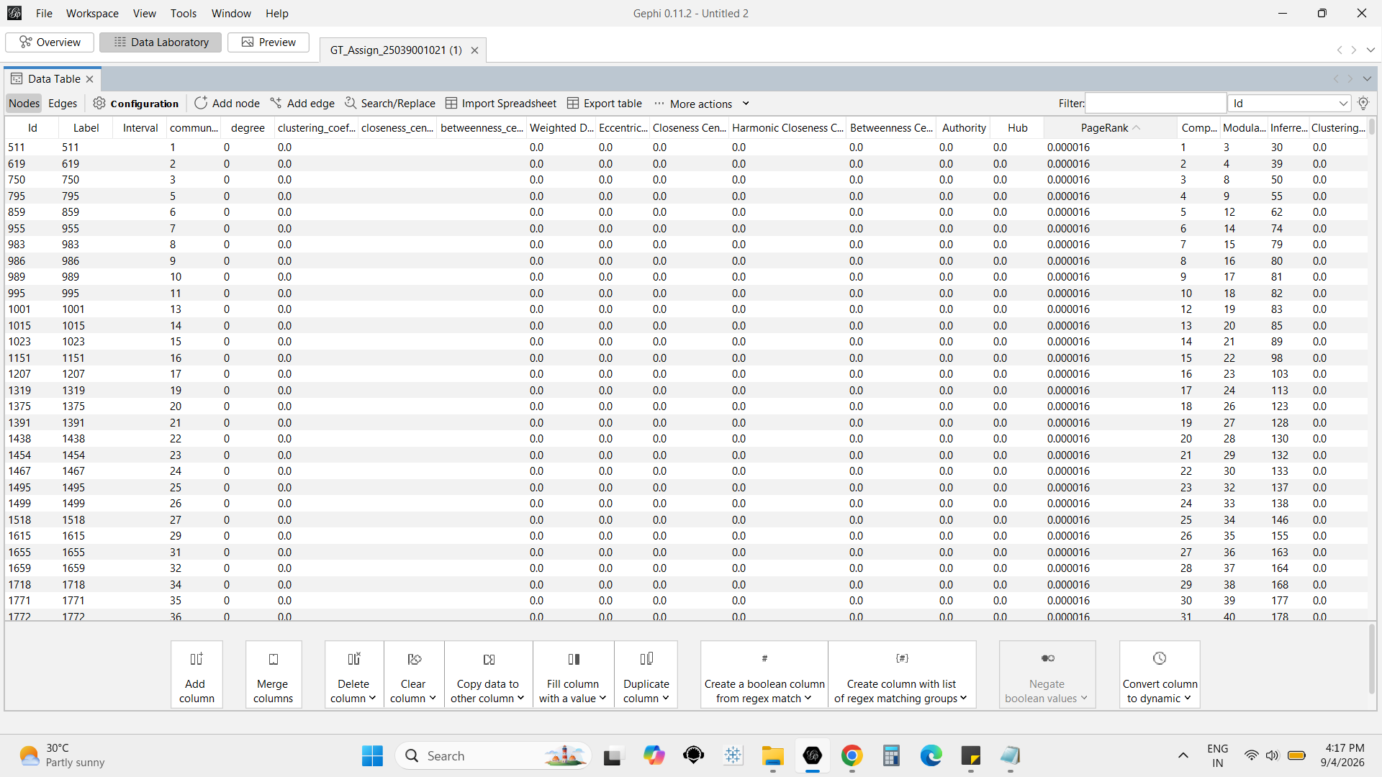
Figure 2: Gephi Data Laboratory with PageRank sorted in descending order.

5.1 Gephi Required Statistics
Required Metric | Gephi Result
Average Weighted Degree | 5.992
Network Diameter | 10
Graph Density | 0.001
HITS | Computed
PageRank | Computed; highest visible node is Node 0

5.2 HITS Results
Rank | Node | Authority | Hub
1 | 0 | 0.210406 | 0.210406
2 | 4 | 0.105639 | 0.105639
3 | 32 | 0.098627 | 0.098627
4 | 2 | 0.096934 | 0.096934
5 | 1024 | 0.096090 | 0.096090
Because the network is undirected, the Authority and Hub values displayed by Gephi are identical for the shown nodes. Node 0 has the highest displayed HITS score.

5.3 Top PageRank Nodes
Rank | Node | Degree | Authority | Hub | PageRank
1 | 0 | 109 | 0.210406 | 0.210406 | 0.001425
2 | 512 | 75 | 0.078124 | 0.078124 | 0.001065
3 | 1024 | 76 | 0.096090 | 0.096090 | 0.001042
4 | 4 | 74 | 0.105639 | 0.105639 | 0.000999
5 | 2 | 70 | 0.096934 | 0.096934 | 0.000997
6 | 32 | 72 | 0.098627 | 0.098627 | 0.000961
7 | 256 | 69 | 0.086960 | 0.086960 | 0.000956
8 | 2048 | 69 | 0.087032 | 0.087032 | 0.000930
9 | 64 | 65 | 0.077522 | 0.077522 | 0.000897
10 | 4096 | 64 | 0.093561 | 0.093561 | 0.000873

5.4 Additional Gephi Findings
Metric | Result
Weakly Connected Components | 1,072
Modularity | 0.332
Modularity Communities | 1,106
Statistical Inference Communities | 3,049
Average Clustering Coefficient | 0.003
Total Triangles | 429
HITS epsilon | 1.0E-8
PageRank epsilon | 0.001
PageRank probability | 0.85

6. Meaningful Insights
- The network contains 10,000 nodes and is sparse, as shown by an average degree of 5.992 and graph density of 0.001.
- The 1,072 weakly connected components indicate that the synthetic network is fragmented into multiple disconnected groups.
- The reported diameter of 10 describes the maximum shortest-path distance within the reachable portion analyzed by Gephi.
- The average clustering coefficient of 0.003 and 429 triangles indicate very limited local triangle formation.
- The modularity value of 0.332 and 1,106 communities indicate measurable community structure.
- Node 0 is particularly prominent, with degree 109, HITS Authority 0.210406, HITS Hub 0.210406 and PageRank 0.001425.
- PageRank and HITS complement degree-based analysis by identifying structurally important nodes.

7. NetworkX and Gephi Comparison
Metric | NetworkX / Python | Gephi
Nodes | 10,000 | 10,000
Average Degree | 5.992 | 5.992
Diameter | 10 (reachable component) | 10
Density | 0.001 | 0.001
Average Clustering | Calculated in notebook | 0.003
Communities | Louvain | 1,106
Modularity | 0.332 | 0.332
HITS | — | Node 0: 0.210406 Authority / Hub
PageRank | — | Node 0: 0.001425

8. Conclusion
A synthetic 10,000-node network was constructed using a stochastic Kronecker graph model. NetworkX was used for programmatic graph construction, visualization, centrality and community analysis, while Gephi was used for scalable visualization and additional statistics including HITS and PageRank. The network is sparse and fragmented but has measurable community structure. Node 0 is a prominent structural node according to degree, HITS and PageRank.

9. Submission Checklist
Deliverable | Required File
Report | GT_Assign_25039001021.pdf
Graph | GT_Assign_25039001021_Final.gexf
Python | GT_Assign_Part_I_Part_II_NetworkX.ipynb
Gephi | GT_Assign_25039001021.gephi

